Midterm Exam (CSCI6339, Fall 2020)
Instructor: Dr. Bin Fu
Due 11:59pm Oct 15, 2020 (Thursday)

Name: Ulvi Bajarani 79/100

ID: 20539914

P1: 17/25, P2: 15/25, P3: 25/25, P4:12/25

Problem 1 (25) Give state diagram of DFA recognizing L={w | w is 0,1-string, and contains 3k 0s and 2m 1s for some integers k and m at least 0}. For examples, 0010111 is in L, but 010011 is not in L. The first string contains 3 0s and 4=2x2 1s, but the second string has an odd number of 1s.

It rejects 11000 that is in the language.

P1: 17/25

Answer 1

In the diagram below, the possible solution of DFA is designed:

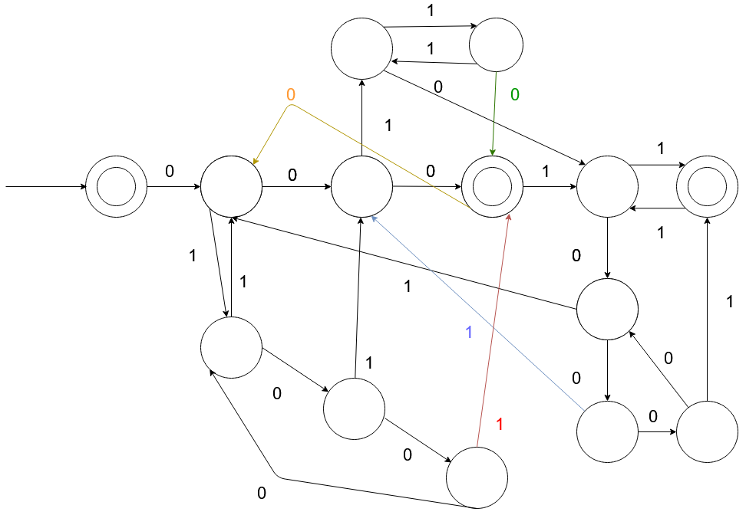

Problem 2 (25)
(a) Prove that the language L1={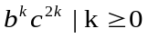} is not regular language with the pumping lemma.

(b) Prove that the language L2={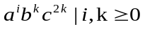} is not regular language with the pumping lemma.

Answer 2

a) To define if the language is regular, let’s have x = b^{k} , y = c^{k}, z = c^{k} . In this case, S and P might be b^{k}c^{k}c^{k} so that |S| ≥ |P| and |xy| ≤ |P|. Let’s pump it to xy²z = b^{k}c^{2k}c^{k} . In this case, the number of c in y is higher than in z. Since we should have an equal number of c in both y and z, we get the contradiction, so L1 is not a regular language.

b) To define if the language is regular, let’s have x = a^{i} , y = b^{k}c^{k}, z = c^{k} . In this case, S and P might be a^{i}b^{k}c^{k}c^{k} so that |S| ≥ |P| and |xy| ≤ |P|. Let’s pump it to xy²z = a^{i}b^{2k}c^{2k}c^{k} . In this case, the number of c in y is higher than in z. Since we should have an equal number of c in both y and z, we get the contradiction, so L2 is not a regular language.

The selection of string S should have a length depending on p. P2: 15/25

Problem 3 (25) Prove that the language L={(M, N): M is a Turing machine and N is a DFA with L(M) =L(N)} is undecidable. You need to derive a reduction from Atm={(M, w)|Turing machine M accepts w} to L.

Answer 3.

Assume that L is decidable. Then, there is the decider Turing machine R such that:

a) giving accept if L(M) = L(N);
b) giving reject if L(M) ≠ L(N);

Define Turing machines M and DFA N, where

a) M accepts any input if A_{TM} returns accept;
b) N rejects all inputs;

Then define the Turing machine S with input <M> such that

1) Runs R on <M, N>.
2) If R gives accept, then S also gives accept. If R gives reject, then S also gives reject.

If the languages are equivalent, then M and N are empty. Otherwise, L(M) ≠ L(N); Since it is not possible to have a decider defining if the language is empty, we can assume that EQ_{TM} is undecidable. Let’s prove the statement regarding E_{TM}:

Design R’ for input <M> such that:

a) giving accept if L(M) is empty;
b) giving reject if L(M) is not empty;

Then, design S’ to decide A_{TM} such that

a) Constructs Machine M₁: if input ≠ w, M₁ rejects.
b) if input = w, run M on w and give accept if M accepts. It is possible only if L(M₁) = {w}.

Then run R’ on the input <M₁>
a) if R’ gives accept, S rejects
b) if R’ gives reject, S accepts

Since S’ gives accept if and only if L(M₁) ≠ Ø , we cannot say if A_{TM} halts on w/or accepts the w, so we get the contradiction.

P3: 25/25

Problem 4 (25). Derive one-one correspondence between the real numbers in (0,1) and the set of irrational numbers in (0,1). Hint: you need to use the fact that the set of rational numbers in (0,1) is countable.

Answer 4.

If we define q=a/b so that 0<q<1 and q ∈ Q, we can start to map. Let’s have the map from q to the real numbers in (0, 1). It might be done by the function

g(a/b) = 1/(2ª3^{b})

Then, map the q to the irrationals in (0,1). Knowing that π is irrational, we can define the function

h(a/b) = a / (b*π).

Then, the composition

F = g ∘ h = g(h(a/b)) is the correspondence between the real numbers in (0,1) and the set of irrational numbers in (0, 1).

You did not consider all cases for the mapping h(.). It does not look like a correspondence. P4:12/25

